|  |
| --- |
| **Divyansh Tripathi**  [**Email- divyanshtripathi04@gmail.com**](mailto:Email-%20divyanshtripathi04@gmail.com)  **Mob. 965053729**  **Security Analyst** |

A passionate security analyst with strong expertise in network security, security policy, and organizational risk management. Seeking an entry-level cybersecurity position to apply my knowledge of SIEM tools and proficiency in standard frameworks and controls, such as the NIST, CSF and CIA Triad model. Committed to continuous learning and keeping up-to-date with the latest industry trends and best practices, I am dedicated to ensuring a secure digital environment and contributing to the success of the organization.

**Work History**

2023-05 - 2023-07

**Security Analyst (Aithent Inc.)**

*Security Analyst and Penetration Tester*

* Contributed to assessing vulnerabilities in various given web applications, performing and preparing pentest reports.
* Analysed network for malicious intrusions and learned to escalate threats.

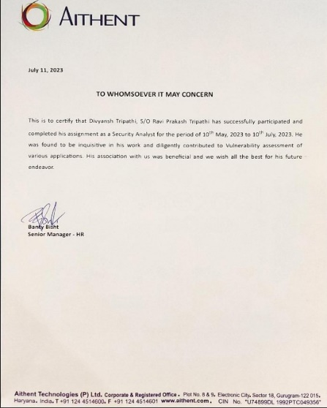

2023-06 - 2023-07

**Web Development Internship (Sparks Foundation)**

*Web Development and Designing Intern*

* Developed a User-friendly banking website with modern JavaScript frameworks, HTML, and CSS.
* Learned Responsive and Fluid Web Designing with tailwind CSS and vanilla JS.

**Education**

2021-10 – Present

**Computer Science Engineering, B.Tech**

*Manipal University Jaipur, Jaipur*

**Skills**

* Risk analysis And Assessment
* Intrusion Detection
* SIEM (Splunk and Chronicle)
* Incident Response
* Network security
* Vulnerability Analysis
* Penetration testing
* Linux
* SQL
* Python
* C/C++ programming
* Front End Web Development
* Cloud Computing

**Certificates**

2023-06

* **Google Cybersecurity Specialization (**[**https://www.credly.com/badges/8bb12295-6f5c-4797-80d4-f9368fc55590/linked_in_profile**](https://www.credly.com/badges/8bb12295-6f5c-4797-80d4-f9368fc55590/linked_in_profile)**)**

2022-10

* **Usable Security (**[**https://www.coursera.org/account/accomplishments/certificate/FP4UQJGXFKZ9**](https://www.coursera.org/account/accomplishments/certificate/FP4UQJGXFKZ9)**)**

2021-11

* **Getting Started with Vulnerability Analysis and Management (EC-Council)**

2022-12

* **Introduction to Cloud Computing (**[**https://www.coursera.org/account/accomplishments/certificate/2Q2N4VUN3NSA**](https://www.coursera.org/account/accomplishments/certificate/2Q2N4VUN3NSA)**)**